**Dark Spectrum**

**Mínimo Projeto Viável**

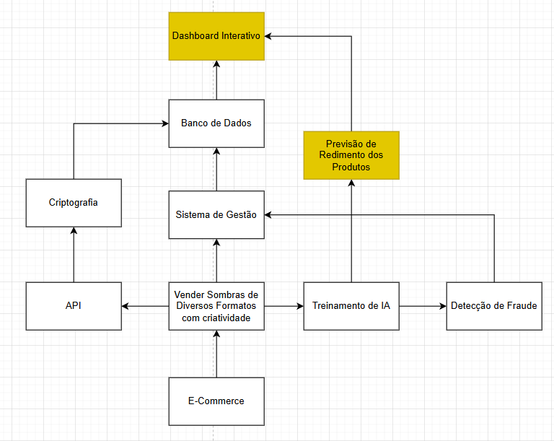

**Link para o diagrama completo:** <https://drive.google.com/file/d/1ouqztlzdrWFJf4heRq0AEcD0f3aWVZKC/view?usp=drive_link>